Want to do all the math in the canperform

Within adcs canperform, calculating ang acc, and storing as state variable

In dependency to antenna, Antenna then would calculate deflection in antenna.py

Dependency collector sweeps up all other subsystem functions and add profiles to create state for x subsystem (power for all subsystems)

Layout subsystems in same as this format :

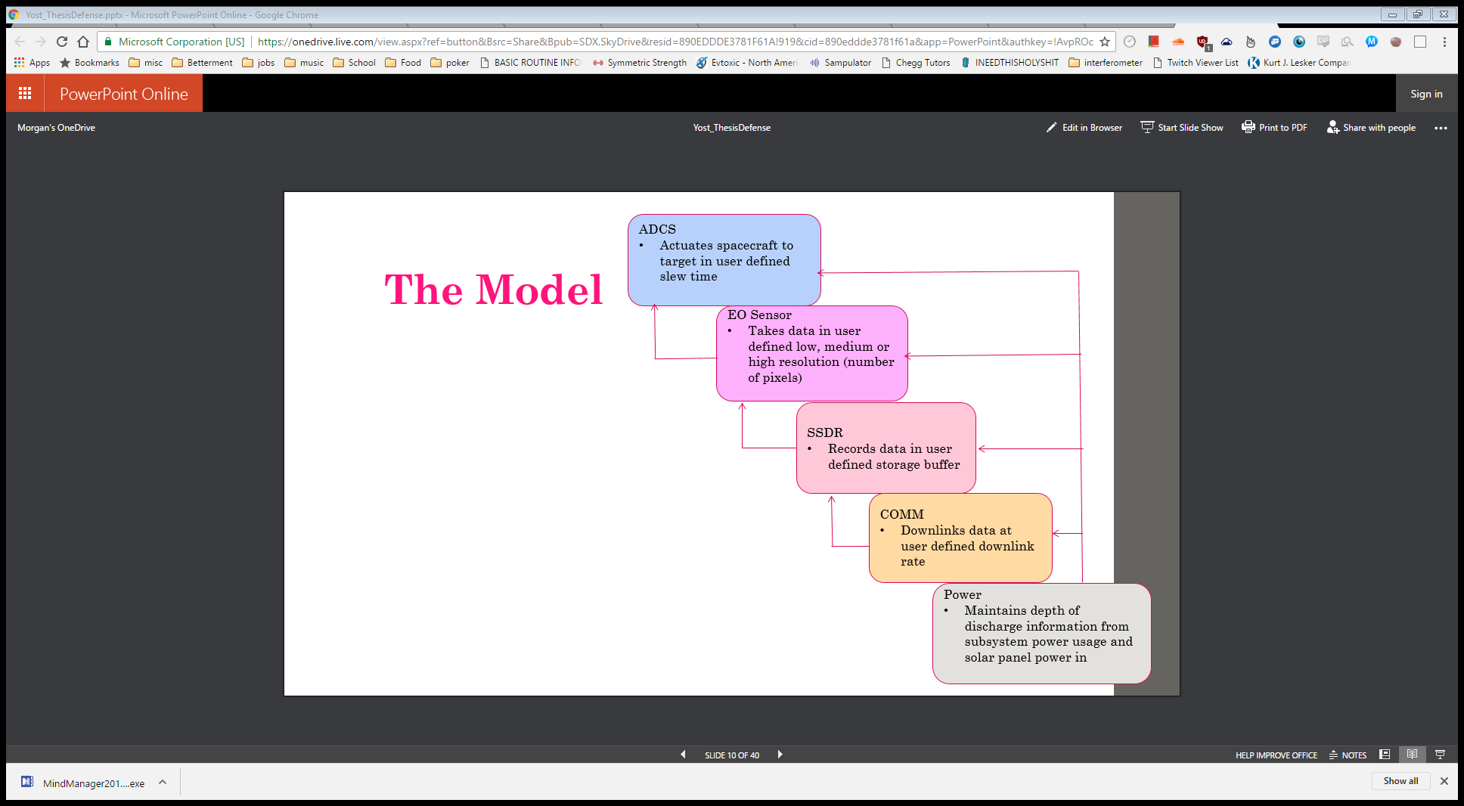

Show states for tracking,

What are dependencies so each susbsystem can calculate its own state

CONOPS

Taking data – next ttimestep available to downlink

Set always try to downlink ? or

Setup for slew for downlink

Ssdr

Stop downlink either because priority not needed or can’t see GS

Trigger adcs - task at hand is image all points on earth

If transmitting data?

Look at the EOSensor bottom of code for example

GOALS:

flowchart with arrows

Click on subsystem block, show canperform code,

Click on arrow, show code for dependency

Need to know orientation of sc relative to eci frame

Seminar:

Talk about horizon, present model, requirements, show how requirements are embedded in model, show data types and mission questions and requirements based on operation of the system,

Implement pointing of satellite tracking for azimuth

Determine ground station locations and orbit used for coverage (find orbit for old Raytheon pushbroom?)

Thesis defense – implement a model based design, show reqs are in model, run various scenarios, try different things to meet reqs and show where it does break is good for the defense!

Able to input requirements for mission performance,